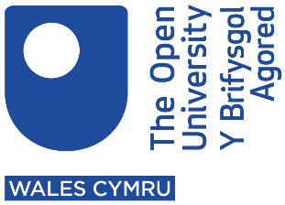
How The Open University in Wales is supporting Wales’ new curriculum
Last updated: August 2021
The table below outlines some of the support The OU in Wales is giving schools and colleges in Wales, and how these align to the Six Areas of Learning and Experience in the new curriculum for Wales.
Key:
l Expressive Arts
l Health and Well-being
l Humanities
l Languages, Literacy and Communication
l Mathematics and Numeracy
l Science and Technology
Area of support | Link to new curriculum | Associated cost
Postgraduate Certificate in Education (PGCE) | l l l l l l
Teachers Learning to Teach languages (TELT) | l
Teaching assistant hub | l l l l l l | Free
Courses for school governors |  | Free
Well-being and mental health collection | l | Free
Take your teaching online | l l l l l l | Free
Moving your language teaching online | l | Free
Direct training to partner colleges |  | Free
Microcredentials |  | £450-£675
OpenLearn and OpenLearn Wales | l l l l l l | Free
Understanding Devolution in Wales |  | Free
University ready | l l l l l l | Free
OU Ambassador Programme | l l l l l l | Free
OpenLearn Champions programme | l l l l l l | Free
OpenSTEM labs | l | Free
Everyday Skills in Maths (bilingual) and English | l l | Free

